Trey Causey
DS&A w/C++ II
7/19/08

Seminar Four Exercise 3 and 4

Graph for exercises
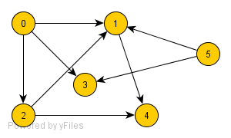
3. List the nodes of the graph in depth first traversal.
0, 1, 4, 2, 3, 5

4. List the nodes of the graph in breadth first traversal.
0, 1, 2, 3, 4, 5

